

COMPUTER SCIENCE
PRACTICAL FILE

Name: Paarth Singh
Class: XII-S1
CBSE Roll no:
Submitted To: Mrs. Sandhya Singh

CERTIFICATE

This is to certify that Paarth Singh of Class XII-S1. Roll No 21 has Completed CS Practical File under my supervision and guidance as per the latest curriculum OF Central Board of Secondary Education (2022-23).

______________________________ __________________________
Examiner’s Signature Principal

_________________________ Institution Rubber Stamp
Teacher In-charge

Date: _______________

ACKNOWLEDGEMENT

In the accomplishment of this practical file successfully, many people have best owned upon me their blessings and the heart pledged support, this time I am utilizing to thank all the people who have been concerned with this practical file. Primarily I would thank God for being able to complete this project with success. Then I would like to thank my Principal Mr. Gaurav Bedi and Computer Science teacher Ms. Sandhya Singh, whose valuable guidance has been the ones that helped me prepare this file and make it a success. Their suggestions and instructions have served as the major contributor towards the completion of the file. Then I would like to thank my parents and friends who have helped me with their valuable suggestions and guidance has been very helpful in various phases. Last but not the least I would like to thank my classmates who have helped me a lot.

Name: _____________________________
CBSE Roll no: ____________________________

CODES:-

Q.1> Write a program to check a number whether it is palindrome or not.
A.1>
SOURCE CODE:-
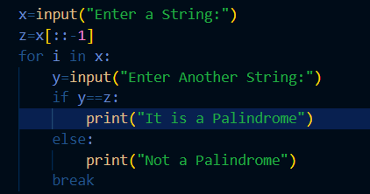

OUTPUT:-
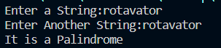
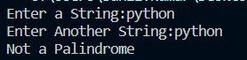

Q.2>Write a program to display the ASCII code of a character and vice-versa.
A.2>
SOURCE CODE:-
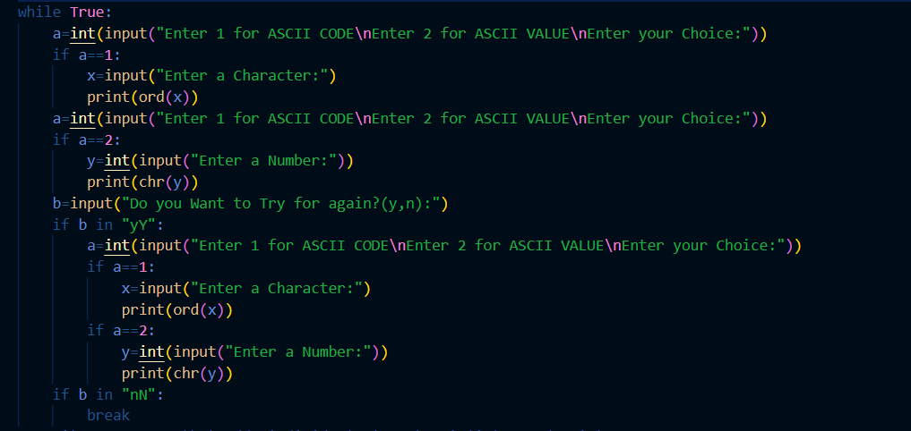
OUTPUT:-
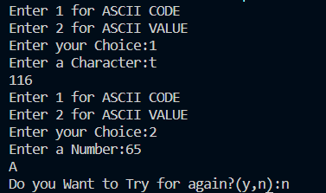
Q.3> Write a program that adds individual elements of list 2 and 3 into 1. Resultant list should be in order of elements of list 3, list1, and list 2.
A.3>
SOURCE CODE:-
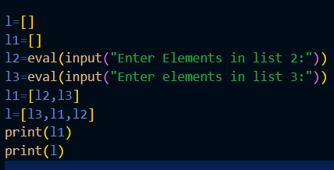

OUTPUT:-
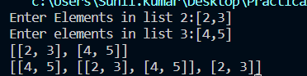

Q.4> Write a program that find an elements index/position in a tuple without using index ( ).
A.4>
SOURCE CODE:-
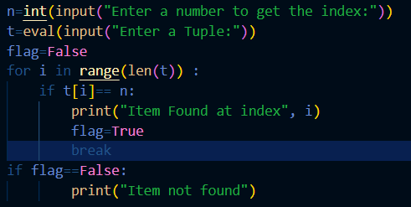

OUTPUT:-
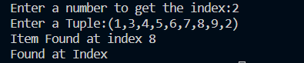

Q.5> Write a program that checks for presence of a value inside a dictionary and prints its keys with ignore case.
A.5>
SOURCE CODE:-
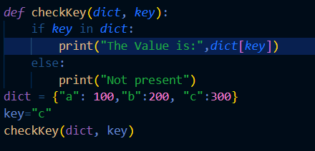

OUTPUT:-

Q.6> Write a program using function that receives two number and return the result of all the arithmetic operations (+,-,*, /, %).
A.6>
SOURCE CODE:-
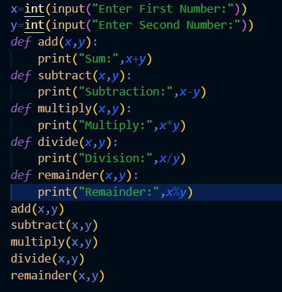

OUTPUT:-
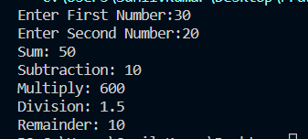

Q.7> Write a menu driven program to calculate: Area of circle [A=πr2] Area of square [A=a*a] Area of rectangle [A=l*b].
A.7>
SOURCE CODE:-
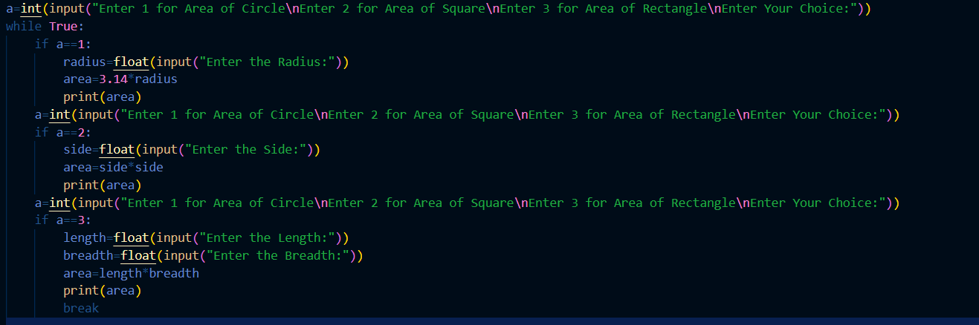
OUTPUT:-
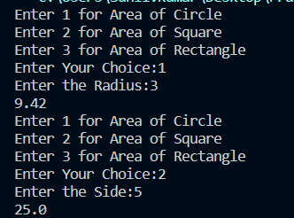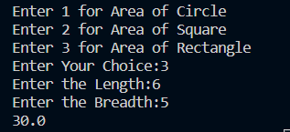
Q.8> Write a program to count the no. of uppercase, lowercase, alphabets, digits in given string/sentence.
A.8>
SOURCE CODE:-
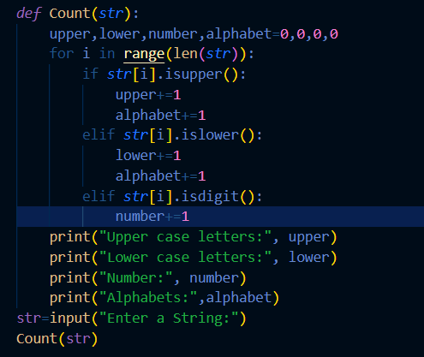

OUTPUT:-
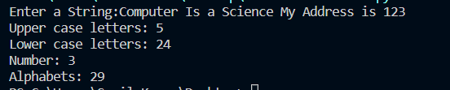

Q.9>Write a program to count number of words in a file.
A.9>
SOURCE CODE:-
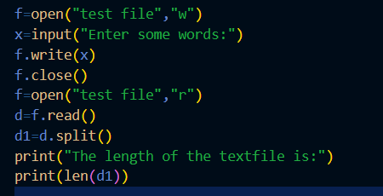

OUTPUT:-
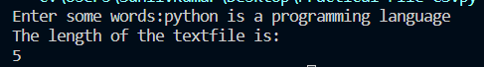

Q.10>Write a Program to read and display file content line by line with each word separated by a “#”.
A.10>
SOURCE CODE:-
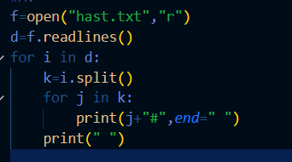

OUTPUT:-
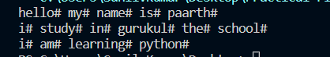

Q.11>Write a program to copy all the lines that not contain the character “a” in a file and write it to another file.
A.11>
SOURCE CODE:-
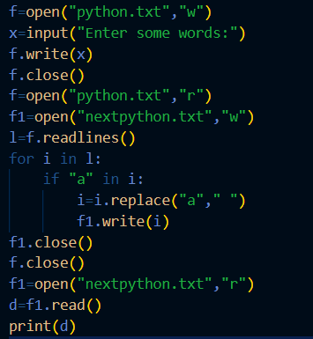

OUTPUT:-

Q.12>Write a program to read the content of a file and display the total number of consonants ,uppercase ,vowels and lowercase characters.
A.12>
SOURCE CODE:-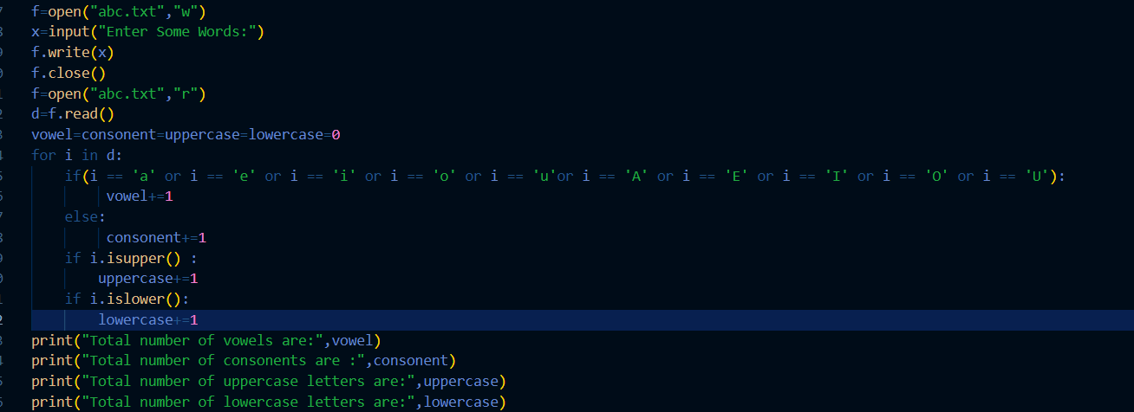
OUTPUT:-
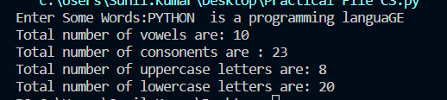

Q.13>Write a program to create a binary file to store roll no and name, search roll no and display name if roll no found otherwise “roll no not found”.
A.13>
SOURCE CODE:-
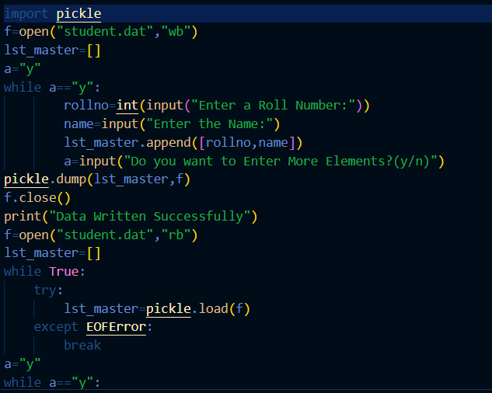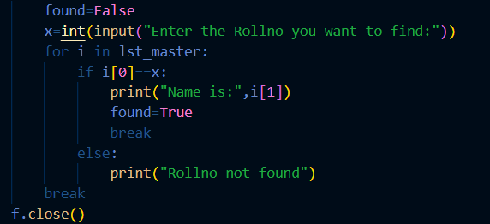

OUTPUT:-
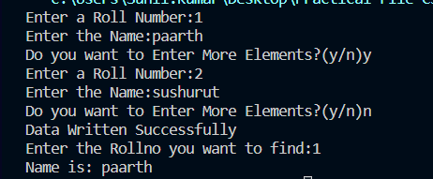

Q.14>Write a program to create binary file to store roll no, name, marks and update marks of the entered roll no.
A.14>
SOURCE CODE:-
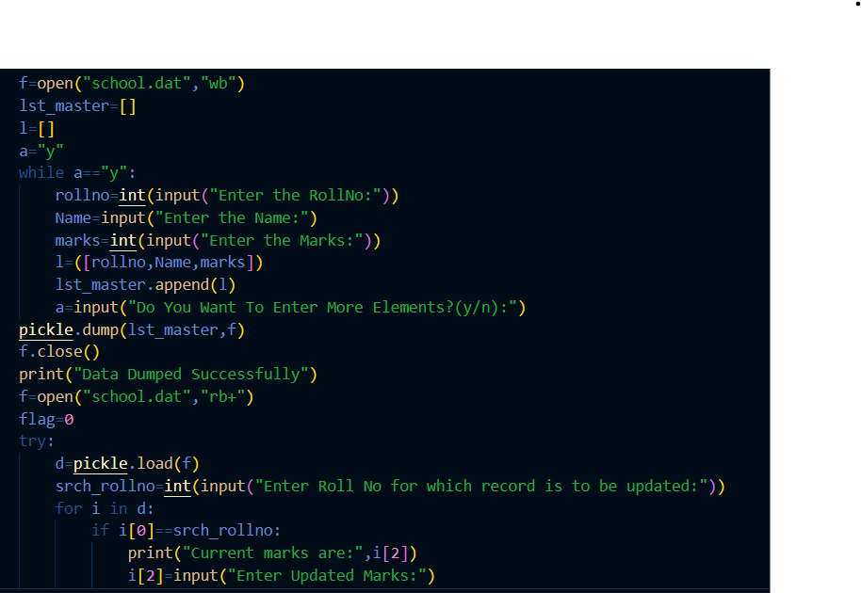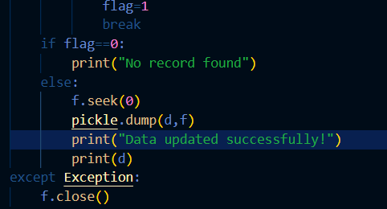

OUTPUT:-
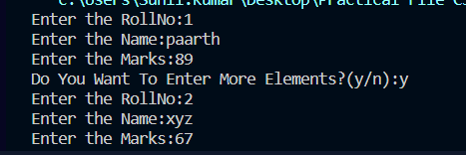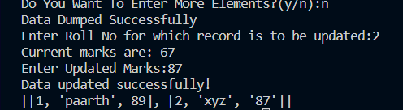

Q.15>Write a program to perform read and write operation with.csv file.
A.15>
SOURCE CODE:-
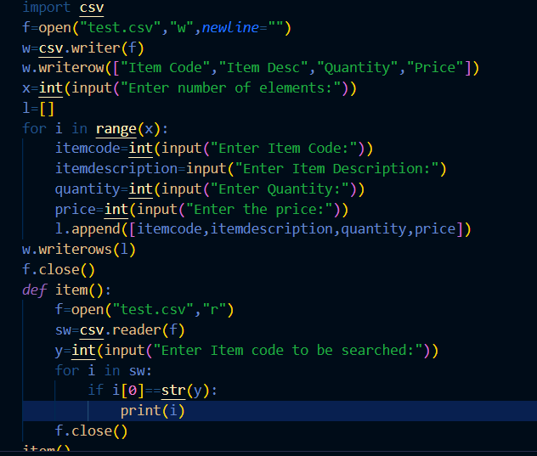
OUTPUT:-
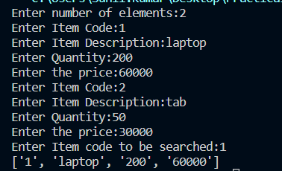
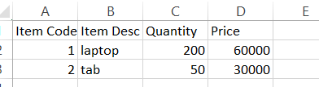

Q.16>Write a menu based program to perform the operation on stack in python.
A.16>
SOURCE CODE:-
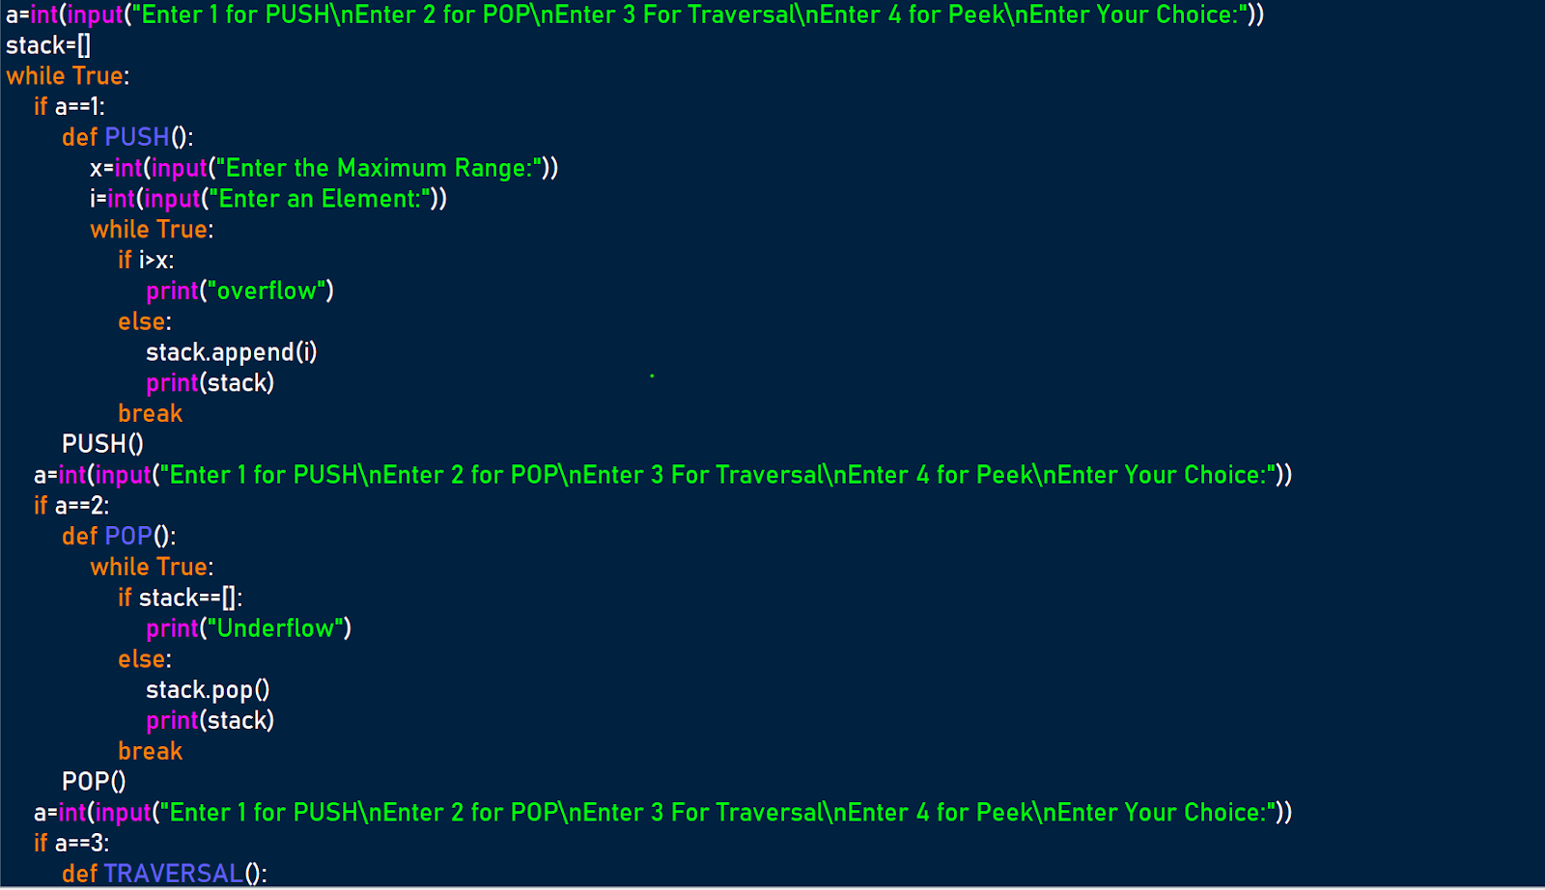
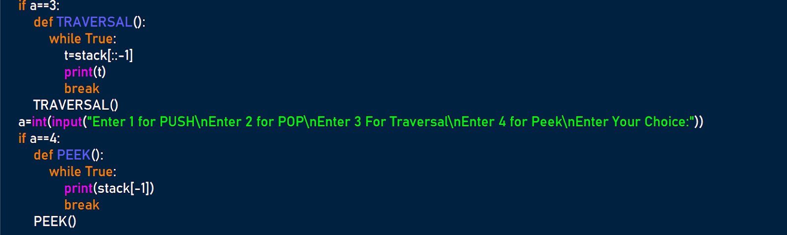

OUTPUT:-
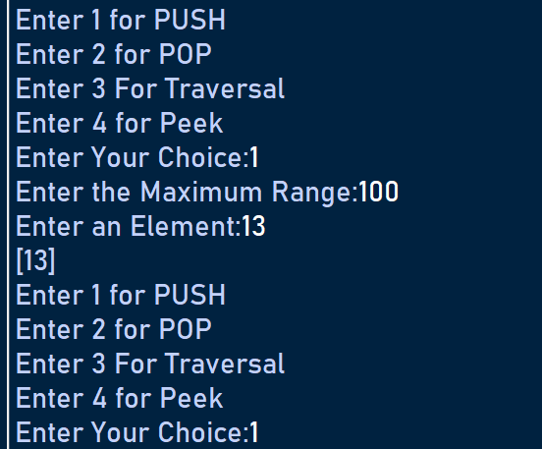
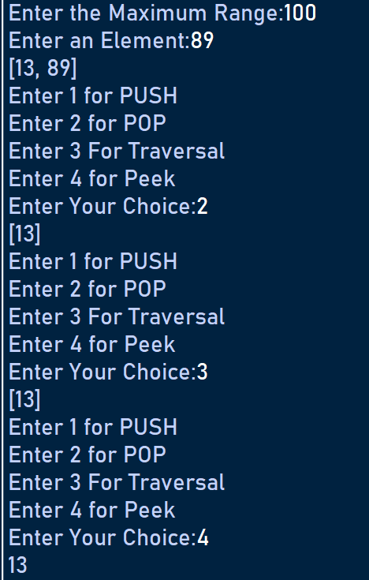

Q.17>Write a menu based program to Maintaining Book details like bcode, btitle and price using stacks in python.
A.17>
SOURCE CODE:-
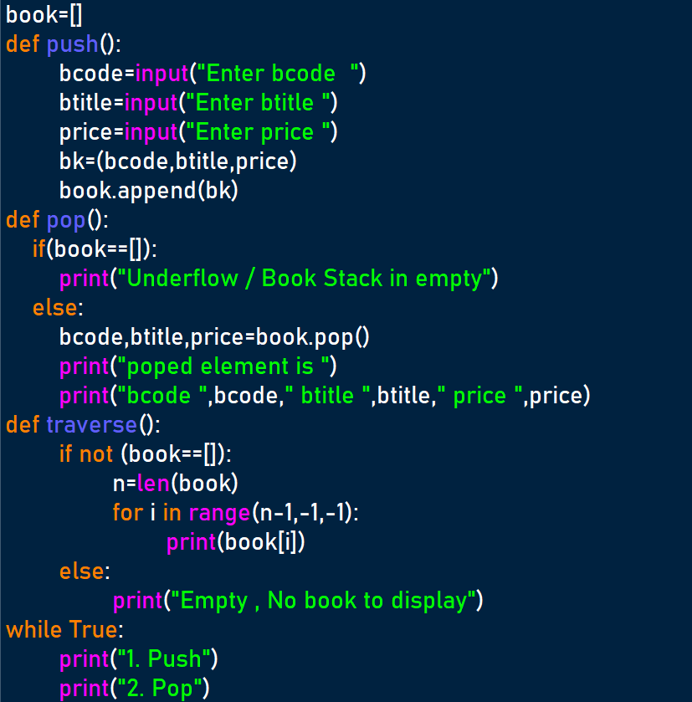
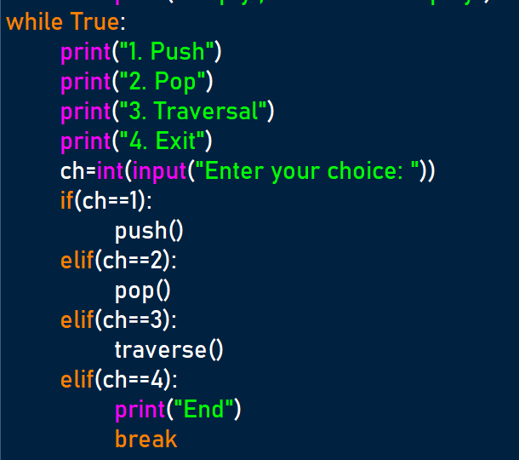

OUTPUT:-
